Amplitude Modulation

EE421 – Experiment 3 Lab Report

by

Aman Khatri, kaman

Experiment performed on 09 March 2012

Report submitted on 13 March 2012

EE 421 - Communications

Department of Electrical and Computer Engineering

The University of Alabama at Birmingham

Lab Team:
Aman Khatri
Mariam Malik Ladhani

Abstract
In communications, a message is transmitted through open space by electromagnetic waves. These electromagnetic waves, also known as modulating signal, generally contain important messages. Since, these waves travel great deal of distances they need a carrier electromagnetic waves on which they can be modulated. There are several ways of modulating messages on the carrier wave and this lab explores one such type of modulation called, Amplitude Modulation. Amplitude modulation is a process in which the amplitude of the carrier wave is made proportional to the amplitude of the baseband signal. The lab consists of analyzing modulation and making it efficient by suppressing the irrelevant components of carrier waves, or by reducing the bandwidth they use for transmission. If the process of making the signal efficient requires suppressing the carrier wave components then such wave is called suppressed sideband suppressed wave (DSB-SC) and if the process requires the carrier components as well as bandwidth components of wave then the wave is called suppressed sideband suppressed sideband wave (SSB-SC).
Table of Contents

Abstract i
Introduction 1
Theory 1
MethodS 3
Experimental Procedure 3
Equipment List 3
Results 4
Conclusions 16
References 16

Introduction

The purpose of this laboratory exercise is to study modulation and demodulation, using Double Sideband Suppressed Carrier (DSB – SC), Double Sideband Larger Carrier (DSB – LC) and Single Sideband Suppressed Carrier (SSB).

Theory¹
DSB-LC:
Modulation is the method of mapping the message signal (Modulating Signal) on to the Carrier Signal. In other words, Amplitude modulation is a process in which the amplitude of the carrier wave is made proportional to the amplitude of the modulating signal. If carrier signal is represented by c(t) = A cos(ω_{c}t) and the baseband signal is represented by x(t) then , according to the definition of amplitude modulation the resultant wave s(t) is represented by
s(t) = x(t) cos(ω_{c}t) + A cos(ω_{c}t)
which is
s(t) = [A + x(t)] cos(ω_{c}t) (1)
The term [A+x(t)] is the envelope of AM wave. Equation 1 represents the signal in the time domain, and its frequency domain representation is represented by
. (2)
If c(t) = A cos(ω_{c}t) and x(t) = V_{m} cos(ω_{m}t) represents the carrier signal and the modulating signal then Eq.1 changes to
s(t) = [A + x(t)] cos(ω_{c}t),
s(t) = A cos(ω_{c}t) + V_{m} cos(ω_{m}t) cos(ω_{c}t),
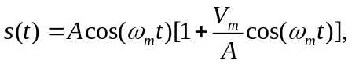 (3)
where the ratio of V_{m} and A is called the modulation index (m_{a}) , and is defined as the measure of extent of amplitude variation about carrier signal. When equation 3, is simplified and the ratio of V_{m} and A is replaced by m_{a} we get

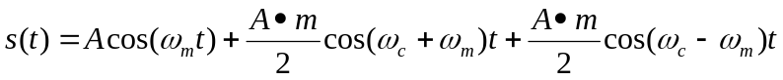 (4)
The expression in Eq.4 reveals that the AM signal has three frequency components
- Carrier frequency ω_{c} with amplitude A.
- Upper Sideband (ω_{c} + ω_{m}) with amplitude 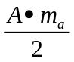.
- Upper Sideband (ω_{c} - ω_{m}) with amplitude
According to Eq.4, the amplitude of the carrier component in the final equation for modulated signal is the same for the modulated carrier wave. Also, there are additional components in the modulated signal which shows that the modulated wave contains more power than the unmodulated carrier. The total power (P_{t}) in the modulated signal is the sum of the carrier power (P_{c}) and the side band power (P_{s}) which can be calculated as shown below:
The carrier power is the mean square of the signal c(t) which is given by
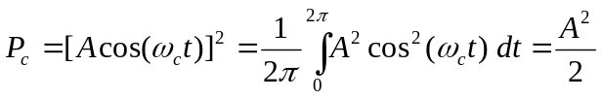. (5)
The sideband power is equal to the mean square value of the sideband term x(t)=V_{m} cos(ω_{m}t) and is given by
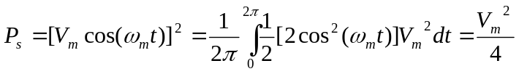 (6)
So, the total power is given by
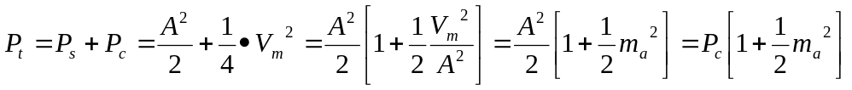 (7)
The Fig.1 shows the AM wave and its Fourier transform as depicted by the equations above. Fig.2 represents the Single-Sided Frequency spectrum of AM wave which is represented by Eq.4
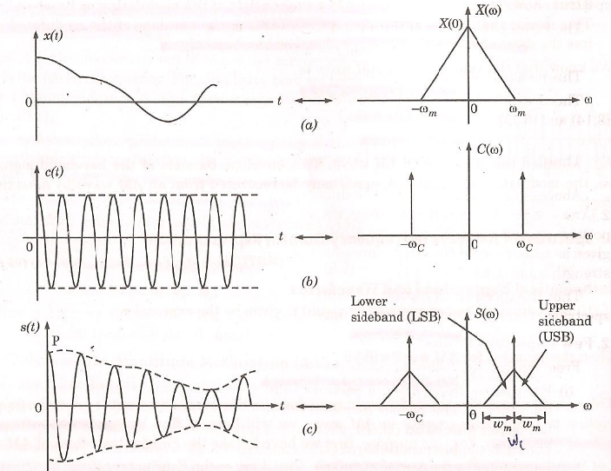
Fig.1 AM Wave and Fourier Transforms
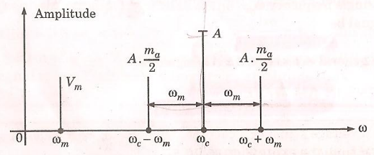
Fig.2 Single Sided Frequency Spectrum of AM wave
DSB-SC:
The Eq.4 represents a Double Sideband full carrier system. When the power dissipated for the above signal (Eq.7) and the ratio of the total power to the carrier power is calculated by using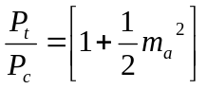, we realize that about 67% of the total power is used by the carrier wave which does not transmits any information. If this wave is suppressed, the power wasted is saved and the resultant wave is called DSB-SC. For DSB-SC the modulated wave is given by (Fig.3)
, (8)
and the frequency domain representation of Eq.4 is given by (Fig.4)
.(9)
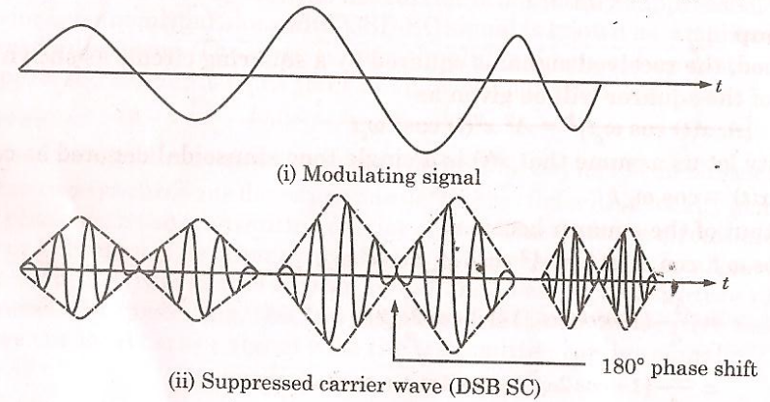
Fig.3 Time Domain Description of DSB-SC
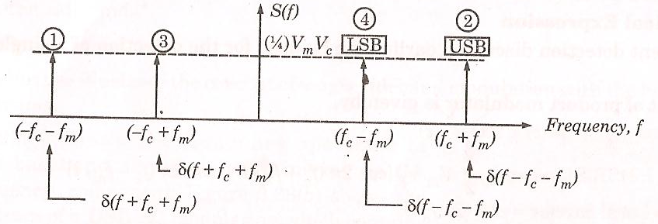3
Fig.4 Double Sided Spectrum of DSB-SC
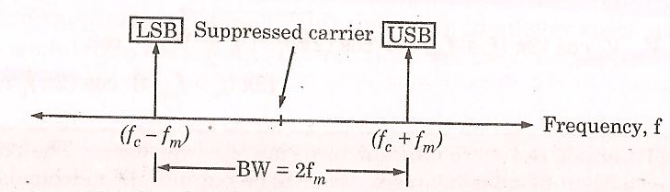
Fig.5 Single Sided Spectrum of DSB-SC
SSB-SC
On further analysis, it is concluded that in DSB-SC the bandwidth used is wasted since it requires a transmission bandwidth equal to twice the message signal bandwidth. In DSB-SC, half of the bandwidth is occupied by upper sideband and the other half of the bandwidth is occupied by the lower side band. Since both the sidebands are identical, one of the side band can be removed while transmitting the signal and can be regenerated at the receiver end without any problem. This leads us to formation of new kind of system which is called SSB-SC where one of the side band is suppressed to save the bandwidth. Consider a single tone modulating signal,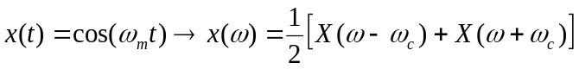, as shown in Fig.[6] . The frequency spectrum of this signal consists of two impulses located at ±ω_{m}, and when this wave is modulated on the carrier signal cos(ω_{c}t), the resulting spectrum of DSB-SC is as shown in Fig. [7b]. To get SSB-SC the LSB is removed from Fig.[7b] which gives us Fig.[7c]. This figure tells that this spectrum is related to a time domain signal given by cos(ω_{c} – ω_{m})t and contains two impulses in its frequency domain. Consider the equation, the positive sign shows the lower sideband and the negative sign represents the upper sideband. Also, we know that 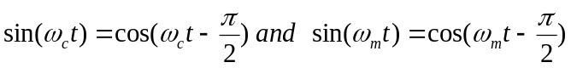so, the corresponding cosine terms can be obtained by using the above identities which leads us to formation of SSB-SC systems.

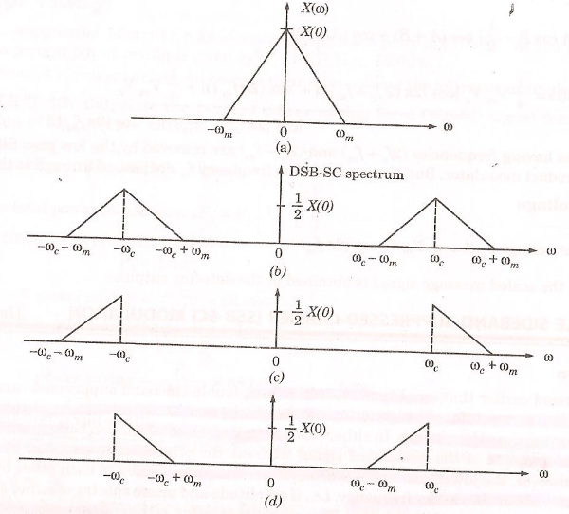
Fig.6 a) Spectrum of Baseband Signal, b) Spectrum of DSB-SC
c) Spectrum of SSB-SC wave with Upper sideband Transmitted
d) Spectrum of SSB-SC wave with Lower sideband Transmitted

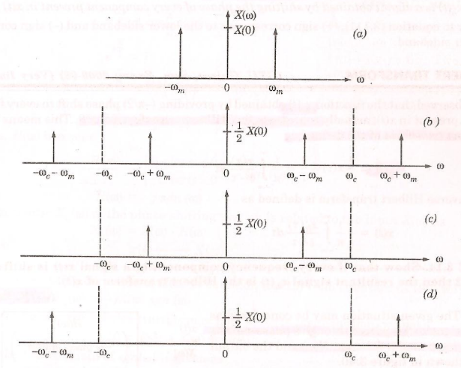
Fig.7 a) Frequency Spectrum of Modulating Signal,
b)Spectrum of DSB-SC wave, c) Spectrum of SSB-SC with lower Sideband,
d) Spectrum of SSB-SC with upper sideband.
Envelope Detection:
The envelope of a wave can be extracted by a diode operating in a linear region. Let us consider the diagram in Fig.8 below:
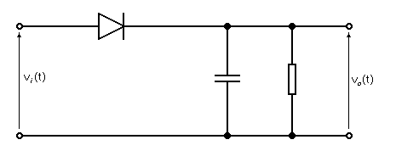
Fig.8 A Linear Diode Detector
In the above diagram, v_{i}(t) is the input terminal and v_{o}(t) is the output terminal. For the positive cycle of the signal s(t), the diode conducts and the capacitor is charged to its maximum value. And, for the negative half cycle, the diode is reversed bias and hence the capacitor discharges to certain value until the next positive cycle enters the input terminal of the circuit resulting in the voltage across the capacitor. This voltage has the magnitude which is same as the envelope of the s(t). Fig. 9 shows how the linear diode detects the envelope.
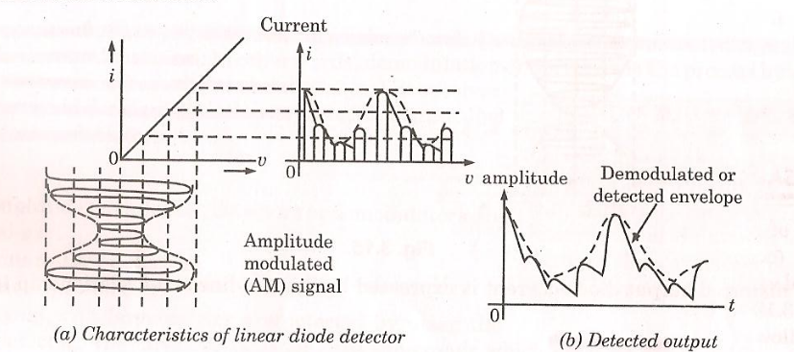
Fig. 9 Detection of Envelope

MethodS

Experimental Procedure
The instructions provided by the instructor were followed.

Equipment List
2 - Agilent 33522A function generators
1 - Wavetek 442 Variable Filter
1- Ideal diode circuit on the Tektronix AM501 Operational Amplifier
1- Agilent MSO-X 2004A Oscilloscope

RESULTS
The instructions in the lab manual were followed, and the following results were generated:
DSB-SC
For step 2 in the section of DSB-SC, the output of channel 1 of the function generator (modulating signal (Green)) and the output of channel 2 of the Function generator (modulated signal (Yellow)) observed on oscilloscope are shown in Fig. 10.
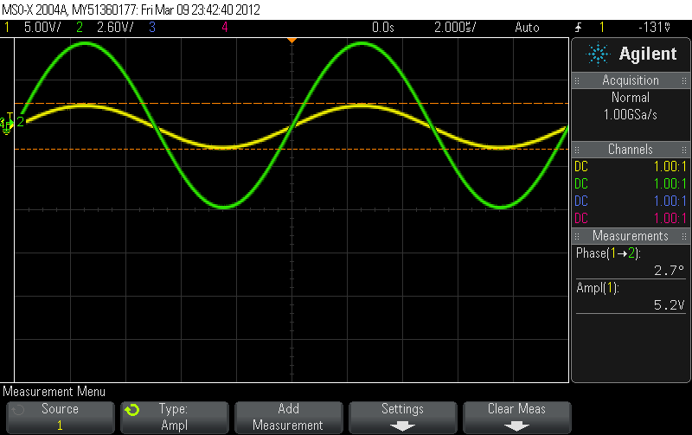
Fig. 10 Modulating and Modulated Signal.
For step 6 in the section of DSB-SC 5 periods of, the output of channel 1 of the function generator (modulating signal (Yellow)) and the output of channel 2 of the Function generator (modulated signal (Green)) observed on oscilloscope in Fig.11. The results were same as expected.
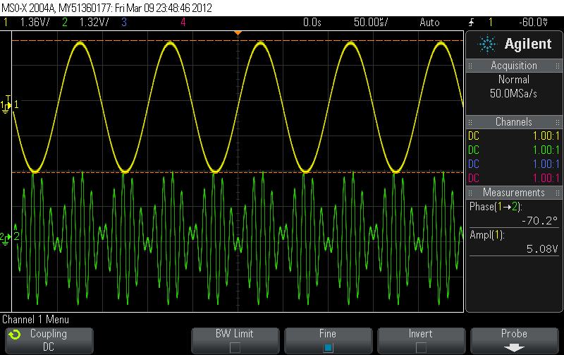
Fig.11 Modulating (Green) and Modulated signals
For steps 8 and 9 in the section of DSB-SC, represents the signals in Fig.12 in frequency domain.
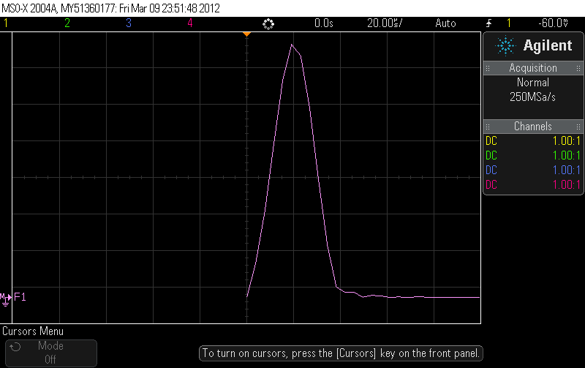
Fig.12 Frequency Domain representation
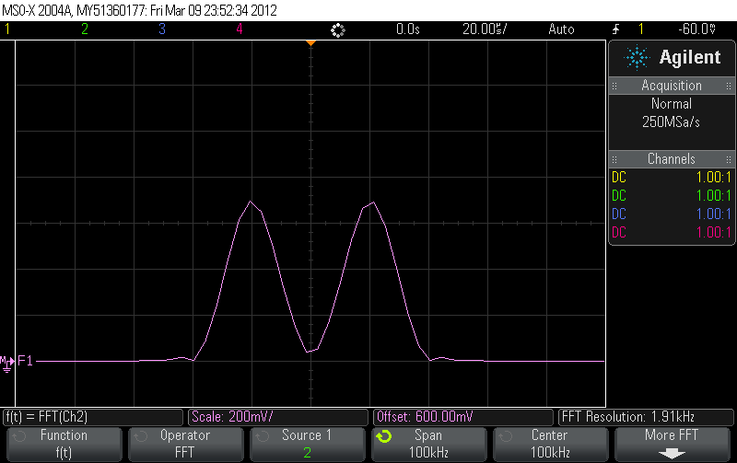
Fig.13 Frequency Domain representation
For step 13 in the section of DSB-SC channel 1 of the modulating function generator (modulating signal (yellow)) and the output of channel 1 of the demodulating Function generator (modulated signal (blue)) observed on oscilloscope in Fig.14. The results were same as expected.
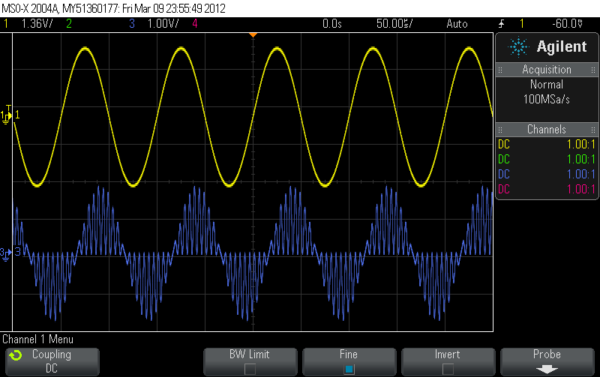
Fig.14 Outputs of Modulating and Demodulating Generators
For step 14 in the section of DSB-SC, the output of the signal obtained from demodulating generator was observed in frequency domain (Fig.15). The frequency components for the resultant wave were same as expected and are represented by the mathematical model depicted by Eq.9 in the section of DSB-SC.

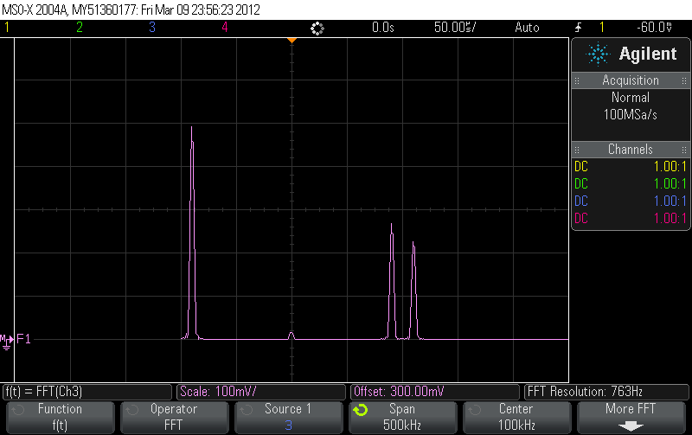
Fig.15 Frequency domain representation of the Modulated Signal
For step 17 and 18 in the section of DSB-SC, the output of modulated wave was passed through the filter and the signals output signal was observed (Fig.16). When the cutoff frequency of the filter was decreased as described in step 18 the distortion in the output signal was observed (Fig.17). This phenomenon occurs due to filtration of components of the resultant waves.
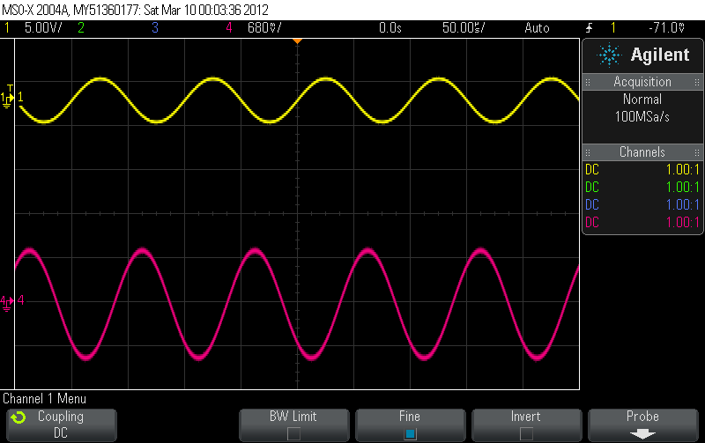
Fig.16 Output from 25 KHz filter

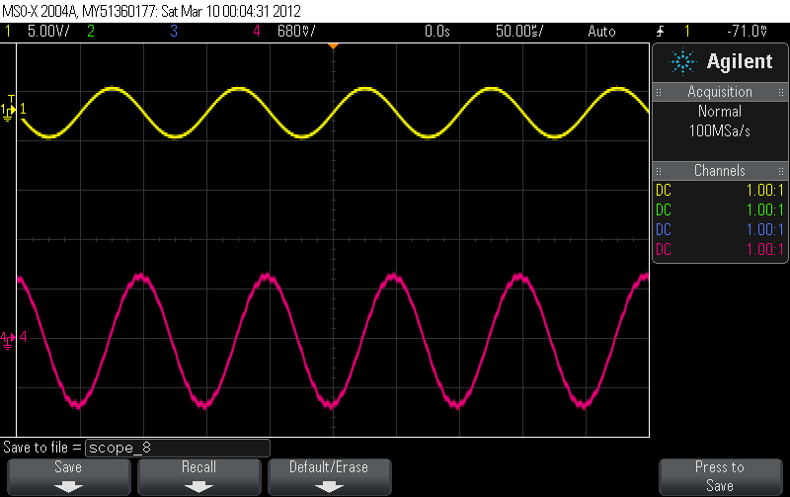
Fig.17 Distorted signal from 10 KHz filter
Explanation: The results under this section can be explained by equations 8 and 9 in the theory section of the DSB-SC. Under the same section, mathematical models have also been used to represent the resultant waves. Eq.8 and Eq.9 yields the same results as observed in the lab.
DSB-LC
For step 1 and 2 in the section of DSB-LC, the output of modulating signal (Yellow) and the output of the modulated signal (Green) for 100% AM depth are shown in Fig. 18 and Fig. 19.
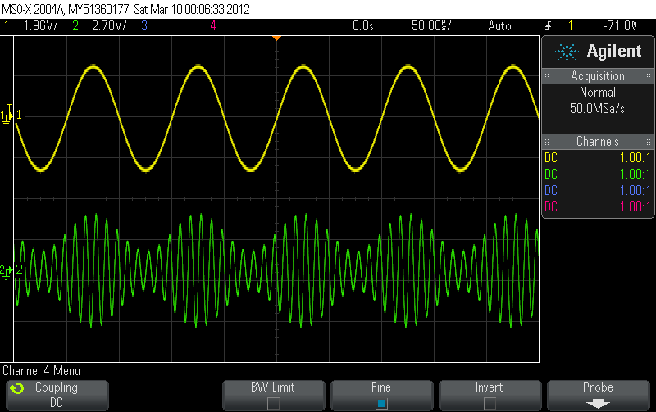
Fig.18 Modulating and Modulated Signals
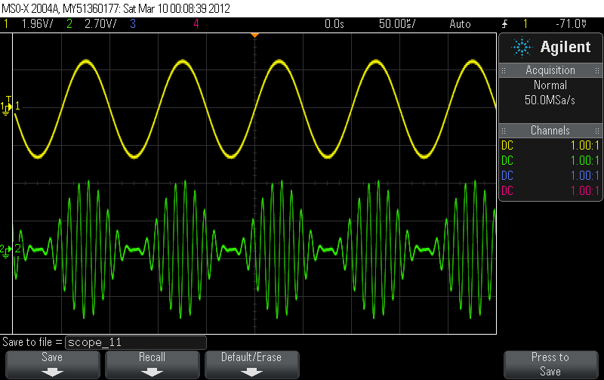
Fig.19 Modulating and Modulated Signals
For step 3 in the section of DSB-LC, the output of modulating signal (Yellow) and the output of the modulated signal (Green) for 0%, 50%, and 120% AM depth are shown in Fig. 21 through Fig. 22. These figures can be explained on the basis of the formulas which relate the message signal to the carrier wave in terms of modulation percentage.

The percentage of the positive modulation on an AM signal is

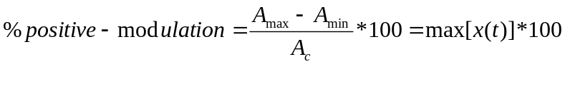
and the percentage of negative modulation is
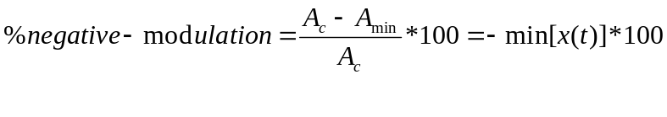
The overall modulation percentage is
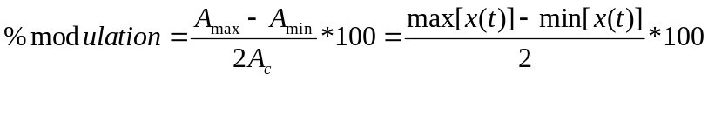

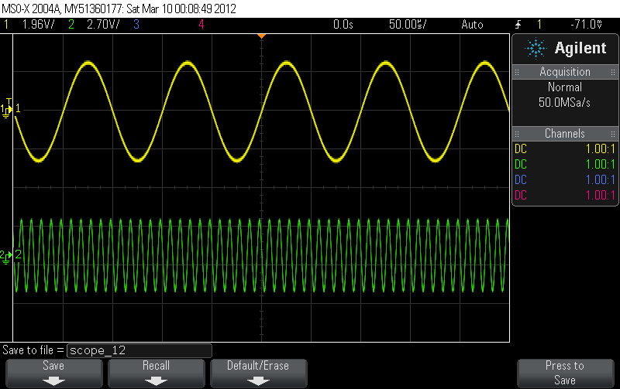
Fig.20 Modulating and Modulated Signals with 0% AM Depth
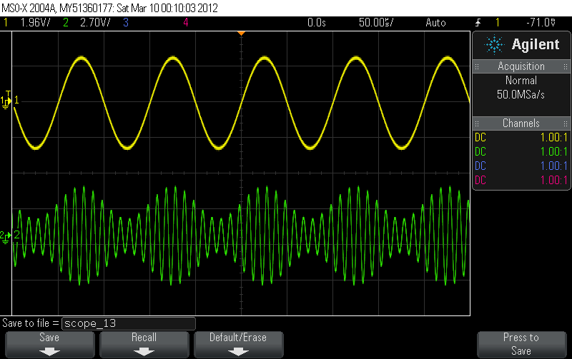
Fig.21 Modulating and Modulated Signals with 50% AM Depth
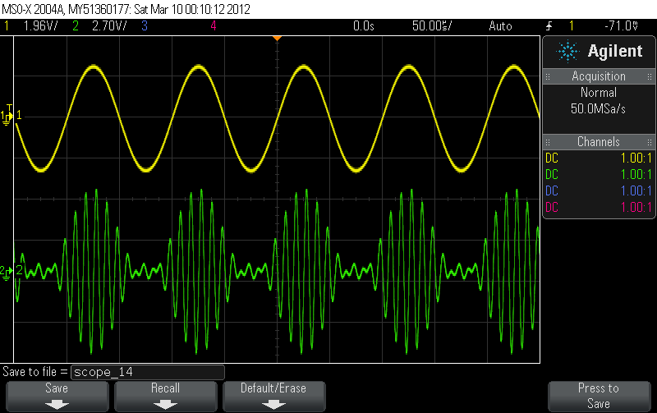
Fig.22 Modulating and Modulated Signals with 120% Depth
For step 5 in the section of DSB-LC, the frequency domain representation of the modulated wave for 100% AM depth is shown in Fig. 23. The frequency components for the resultant wave were same as expected and are represented by the mathematical model depicted by Eq.2 in the section of DSB-LC.

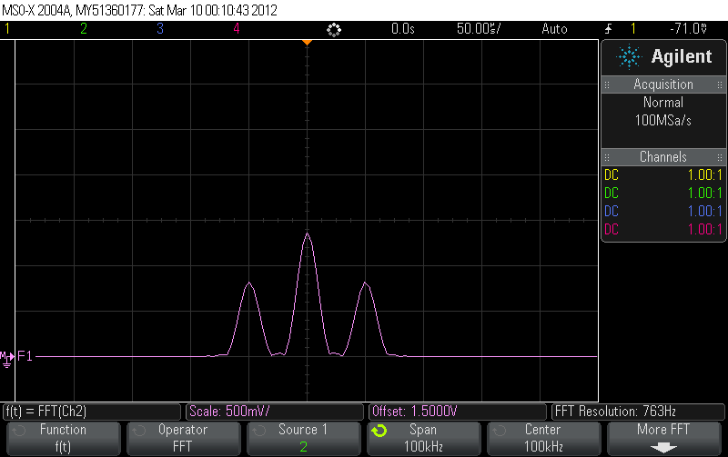
Fig.23 Frequency domain representation of Modulated Signal
For step 8 in the section of DSB-LC, five periods of the modulating signal (Red) and the modulating signal (Blue) are shown in Fig. 24. Fig.25 shows the frequency domain representation of the resultant wave. They were observed to be same as expected. These signals are represented by the mathematical model depicted by Eq.2 in the section of DSB-LC.

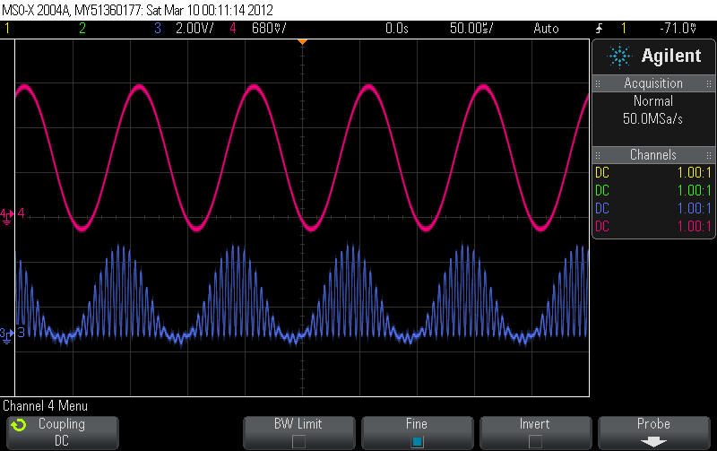
Fig.24 Modulating and Modulated Signal
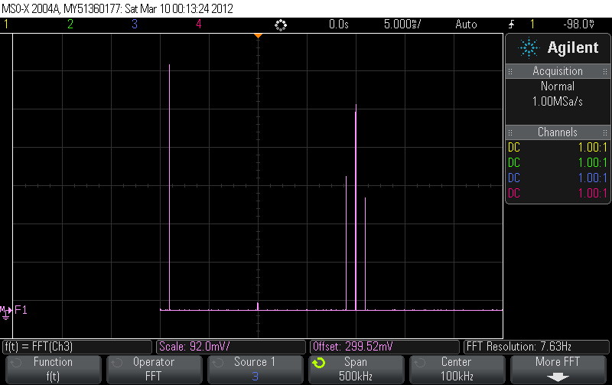
Fig.25 Frequency domain representation of the wave in Fig.24
The output of the ideal diode for the AM depth 0%, 50%, 100, 120 in time domain is representated in Fig. 26,27,28,29 and the frequency domain representation is represented in Fig.30,31,32,33 and 34. These figures can be explained on the basis of the formulas which relate the message signal to the carrier wave in terms of modulation percentage.

The percentage of the positive modulation on an AM signal is

and the percentage of negative modulation is
The overall modulation percentage is

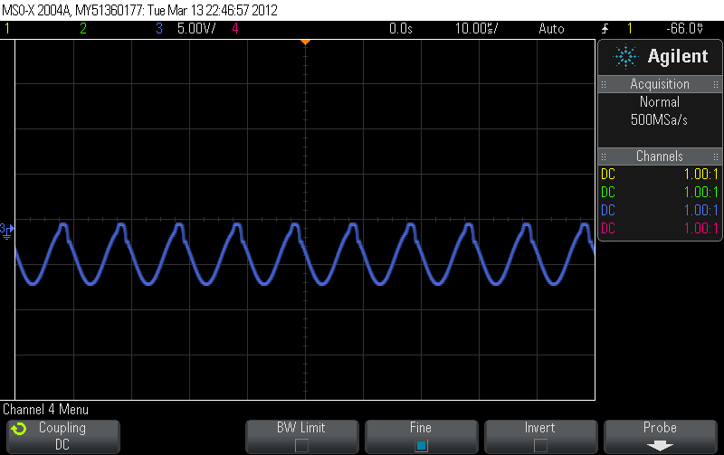
Fig.26 Output with 0%AM depth

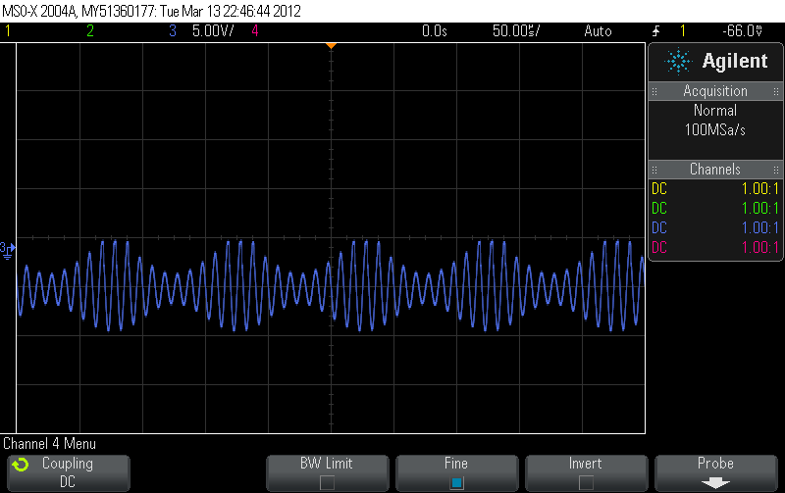
Fig.27 AM Depth 50%
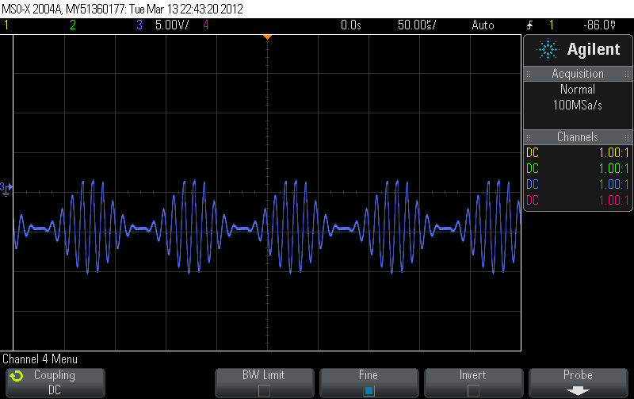
Fig.28 AM Depth 100%
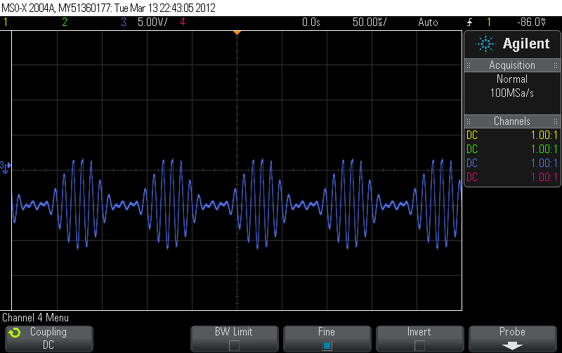
Fig.29 AM Depth 120%

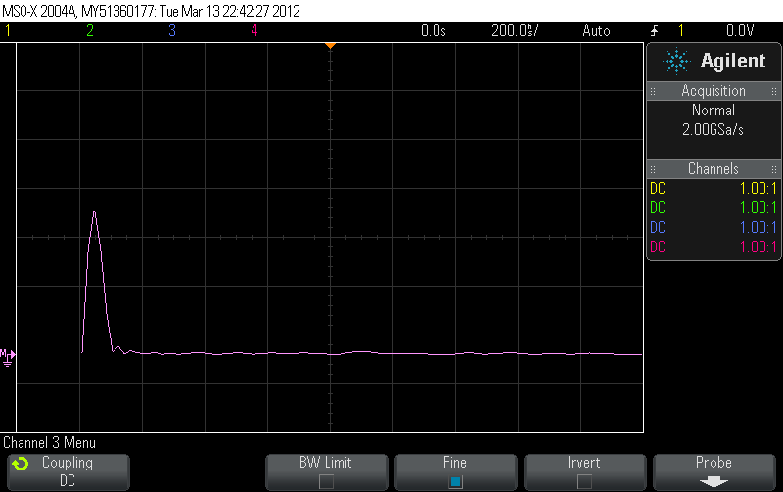
Fig.30 Frequency Domain Representation for 0% AM Depth
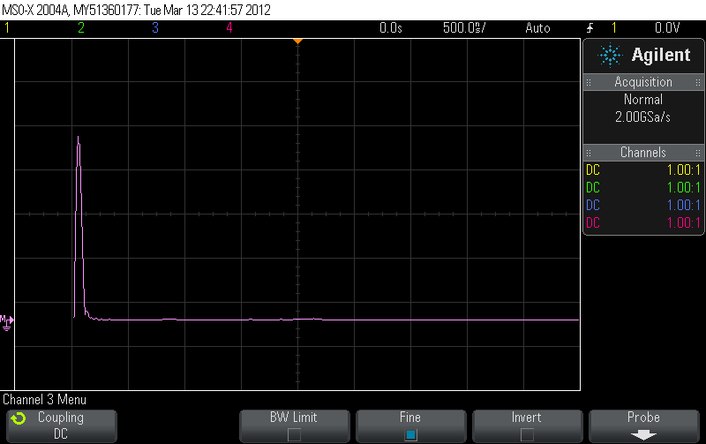
Fig.31 Frequency Domain Representation for 50% AM Depth
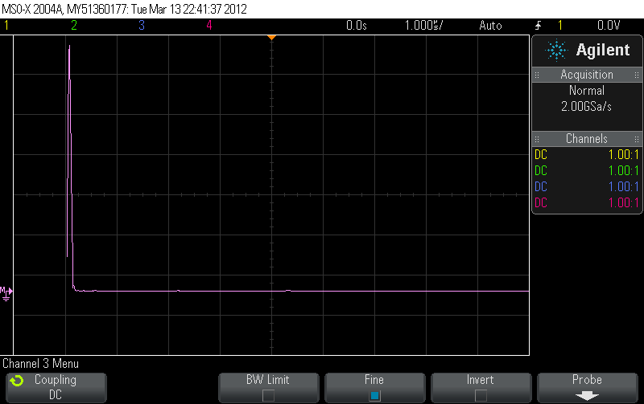
Fig.32 Frequency Domain Representation for 100% AM Depth
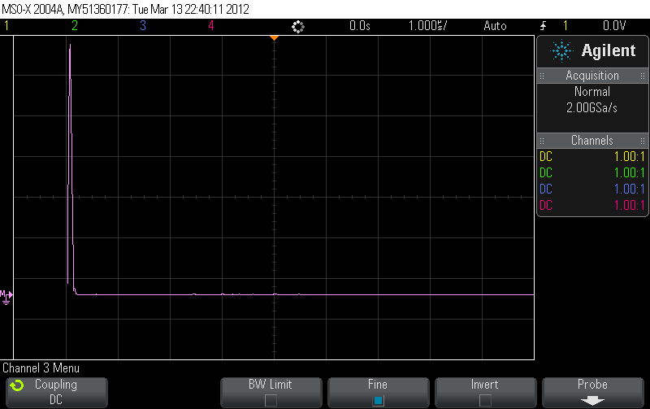
Fig.33 Frequency Domain Representation for 120% AM Depth
Explanation: The results under this section can be explained by equations 8 and 9 in the theory section of the DSB-LC. Under the same section, mathematical models have also been used to represent the resultant waves. Eq.2 and Eq.4 yields the same results as observed in the lab.
SSB-SC
For step 1 in the section of SSB-SC, the output of the adder is shown in Fig.34 and the frequency domain representation of output is shown in Fig.35.
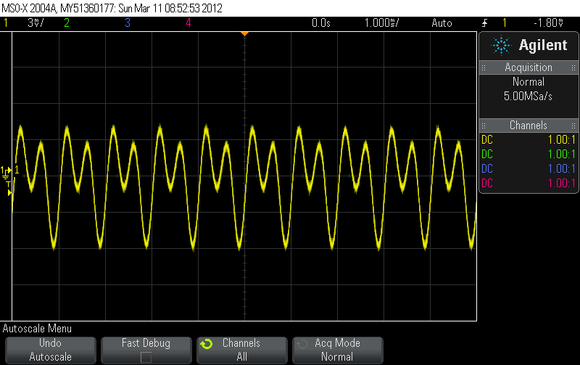
Fig.34 Output for the adder in time domain
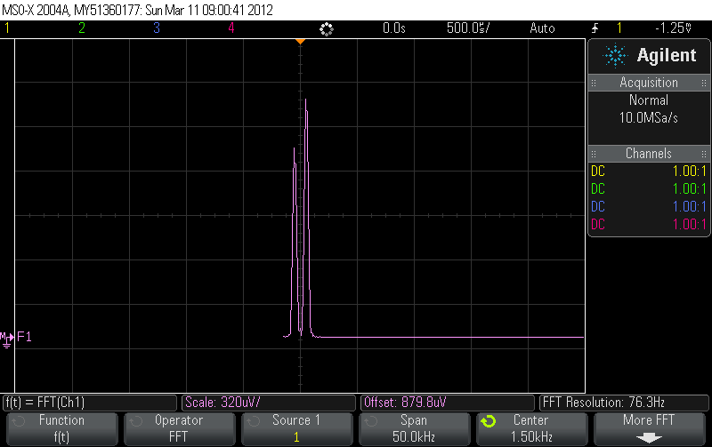
Fig.35 Output of the adder in frequency domain
For step 2 in the section of SSB-SC, the output of the modulator is shown in Fig.36 and the frequency domain representation of output is shown in Fig.37
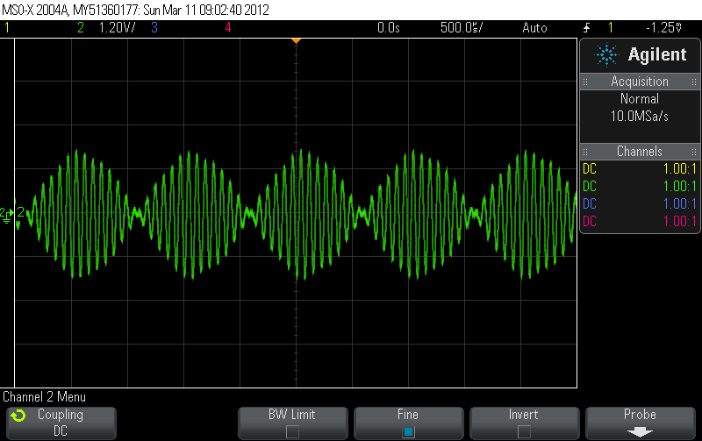
Fig.36 Output of modulator in time domain
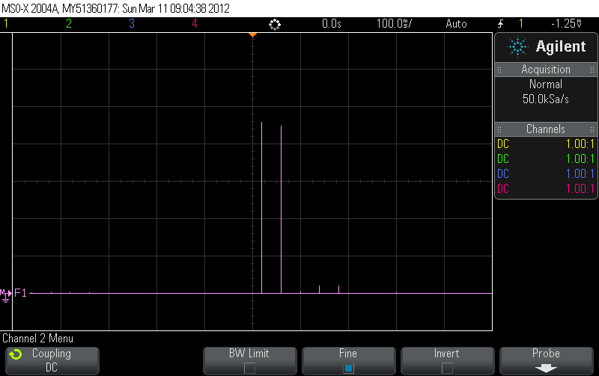
Fig.37 Output of modulator in frequency domain
For step 3 and 4 in the section of SSB-SC, The time domain representation of the output of the modulator is shown in Fig.38. The lower side band and higher side band frequency domain representation of output is shown in Fig.39 and Fig. 40.

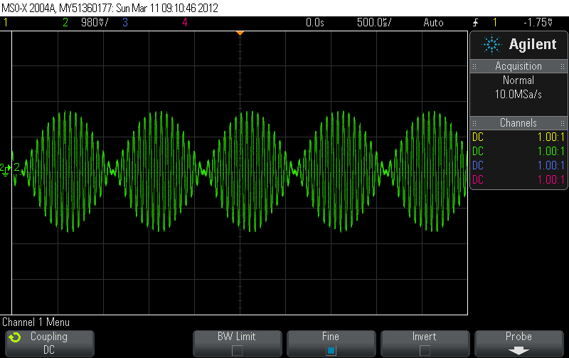
Fig.38 Modulated Signal
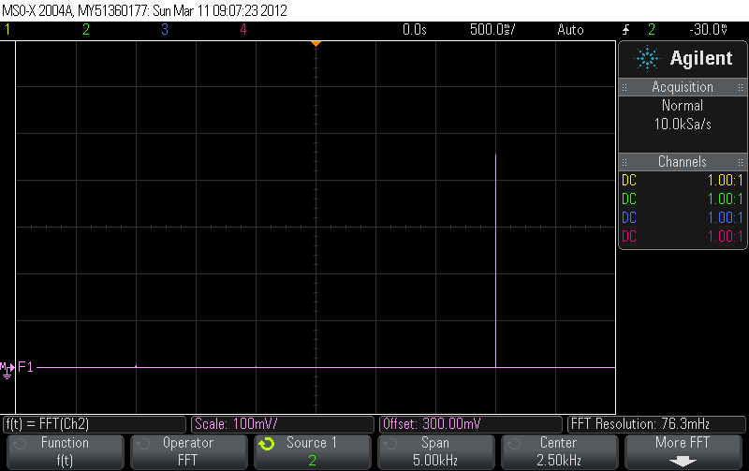
Fig.39 Lower Sideband in Frequency Domain
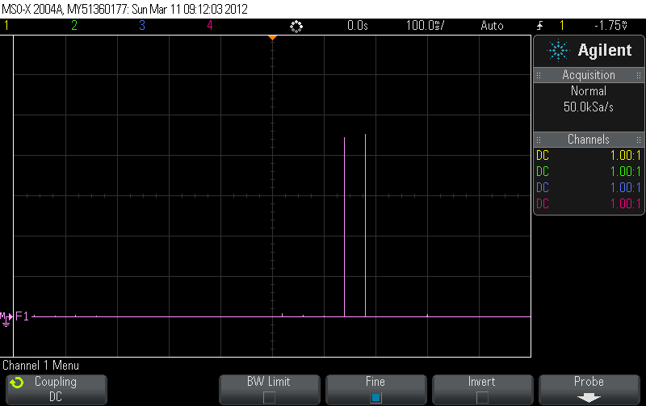
Fig.40 Upper Sideband in Frequency Domain
For step 5 and 6 in the section of SSB-SC, Fig.41 shows the time domain representation of the modulated signal. The output of the modulator for upper band is shown in Fig.42 and the lower side band frequency domain representation of output is shown in Fig.43
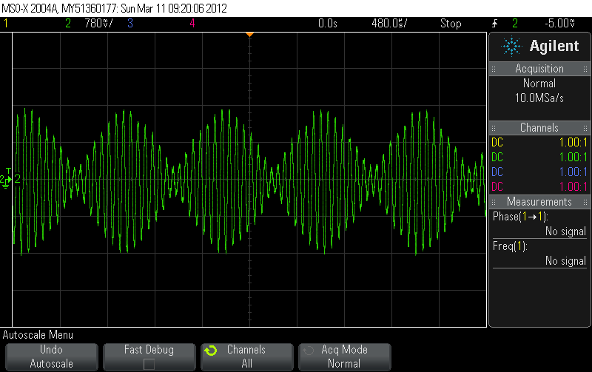
Fig. 41 Modulated Outputs
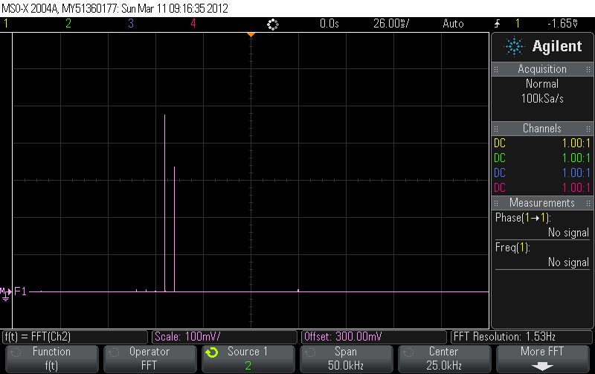
Fig.42 Lower Sideband in Frequency Domain
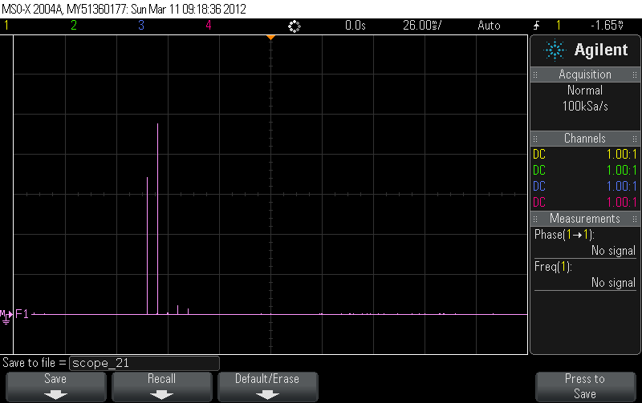
Fig.43 Upper Sideband in Frequency Domain
For step 7 in the section of SSB-SC, the time domain representation of modulated signal is shown in Fig. 44. The output of the modulator in frequency domain (LSB) is shown in Fig.45. Fig. 46 shows the upper side band for the output of the modulator.
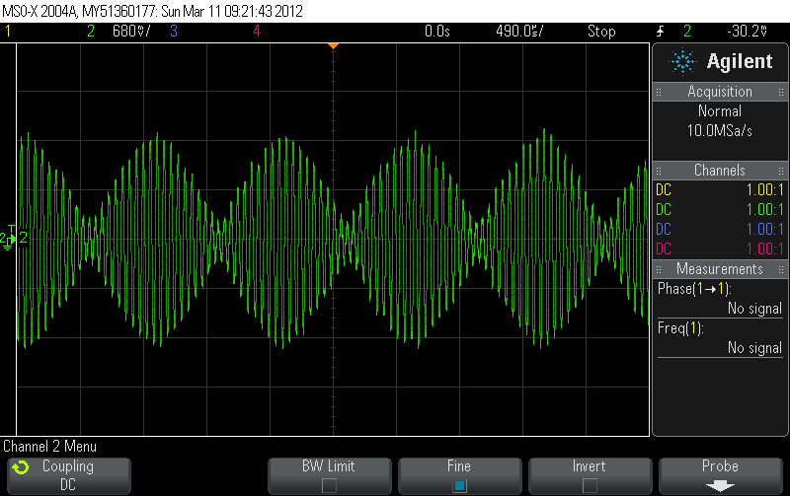
Fig.44 Modulator Output
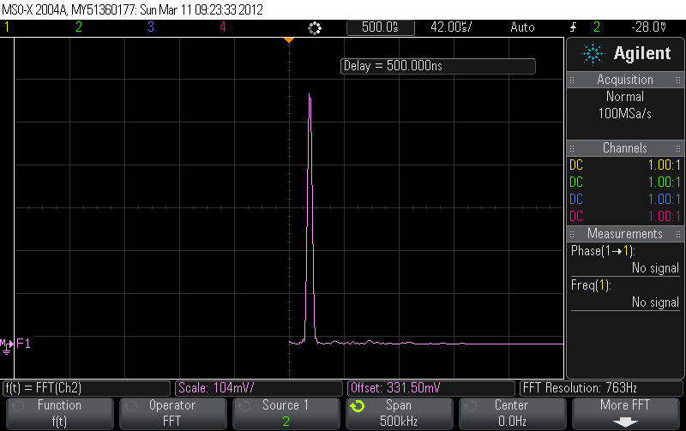
Fig.45 Frequency domain Output for LSB
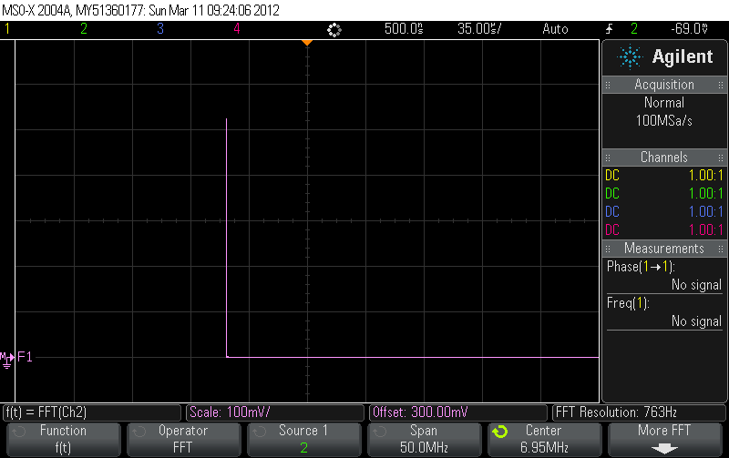
Fig.46 Frequency domain Output for USB
Explanation: The results under this section are explained in the theory section of the SSB-SC. Under the same section, mathematical models have also been used to represent the resultant waves.
The experiment was very useful in understanding the concept of amplitude modulation. The experiment also helped us understand the method of recovering the digital signal using amplitude modulation. Experience was gained in using equipments such as spectrum analyzer and low-pass filter, which will be useful in future experiments.

REFERENCES
- Leon w. Couch, II, “Digital and Analog Communication Systems”, Amplitude Modulation, pp. 303-313 ,2007.

